Review of Statics

Equation of Condition(s)
${(ΣM_{hingeB})}_{BA}=0={(ΣM_{hingeB})}_{BC}$
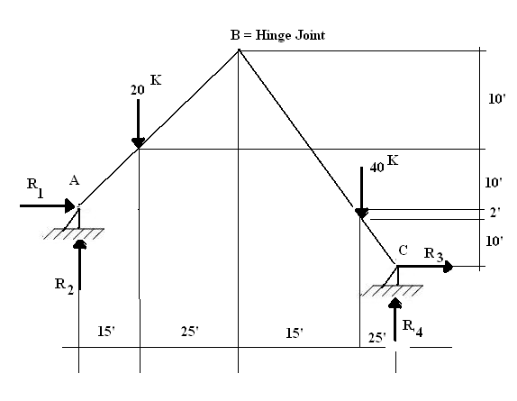
Method 1: solving 4 simultaneous equations

$$ΣF_{x}=0{\overset{→}{=}}^{+}R_{1}+R_{3}≡f_{1}\left(R_{1},R_{3}\right)=0$$
$$ΣF_{y}=0_{ =}^{ ↑+}R_{2}+R_{4}-{20}^{K}-{40}^{K}≡f_{ 2}\left(R_{2},R_{4}\right)=0$$
$Σ{M_{A}}_{ =}^{}0=-\left({20}^{K}\right)\left({15}^{'}\right)-\left({40}^{K}\right)\left({55}^{'}\right)+\left(R_{3}\right)\left(12^{'}\right)+\left(R_{4}\right)\left({80}^{'}\right)=0$
$f_{3}(R_{3},R_{4})$
${{{{(ΣM_{B})}_{BA}}_{ =}^{}0=(20}^{K})\left({25}^{'}\right)+\left(R_{1}\right)\left({20}^{'}\right)-\left(R_{2}\right)\left({40}^{'}\right)=f_{4}(R_{1},R}_{2})=0$ ……(Eq.123)

Method 2:
$ΣM_{A}=0^{}=f_{1}(R_{3},R_{4})$
Solve for ${R_{3},R}_{4}$
$${{{(ΣM_{B})}_{BC}}_{ =}^{}0=f_{2}(R_{3},R}_{4})$$
$ΣM_{C}=^{}0=f_{3}\left(R_{1},R_{2}\right)=\left({40}^{K}\right)\left({25}^{'}\right)+\left({20}^{K}\right)\left({65}^{'}\right)-\left(R_{1}\right)\left({12}^{'}\right)-\left(R_{2}\right)({80}^{'})$
Solve for $R_{1},R_{2}$
$${(ΣM_{B})}_{BA}=^{}0=f_{4}\left(R_{1,}R_{2}\right)=see Eq.(123)$$
Chapter 6 : Analysis of Structures

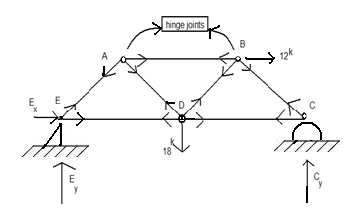
- Method of Joints
FBD of Joint B

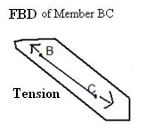

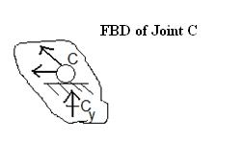
*Each TRUSS member
is connected by 2
“hinge joints”

*A “hinge” join can
transfer forces, but NOT moments
*Truss members can only carry
Axial forces

- How to Compute Truss Member Forces
$ΣF_{x}= 0$
Step 1: Apply 3 equilibrium eqs. $ΣF_{y}= 0$
To find 3 unknown reactions $ΣM_{z-axis}=0$

Step 2: At each joint which has 2 (or less) unknown member force(s),
apply 2 (force) equilibrium eqs $ΣF_{x}=0$
to find 2 (or less) member force(s) $Σf_{y}=0$

Step 3: Repeat step 2 until all (or few desired) member force(s) are found.

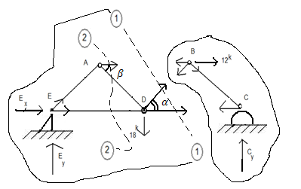
- Method of Sections

This method is useful
if one has interests to
compute only few selected
(not ALL) member forces,
such as member forces
AB, DB, AD

Step 1: Apply 3 equilibrium eqs. for the entire structure to find 3 unknown reactions.

Step 2: Make an “intelligent and honest” cut section (1)-(1)
Then, decide “which side” of the cut to draw FBD, say LEFT side!
Step 3: Apply 3 equilibrium eqs, using LEFT – FBD:

$$∑M_{D}=0⇒f_{1}\left(F_{AB},E_{x},E_{y}\right)=0→solve for F_{AB}$$

$∑F_{x}{}_{=}^{→}{{}_{}^{+}0}⇒f_{2}\left(E_{x},F_{DC},F_{DB}cosα,F_{AB}\right)=0→solve for{ F}_{DC}$
$↑$
$$∑F_{y}{}_{=}^{↑}{{}_{}^{+}0}⇒f_{3}\left(E_{y},-{18}^{k},F_{DB}sinα\right)=0→ solve for{ F}_{DB}$$

Notes: The remaining member force $F_{AD}$can be found by:
*Apply Method of Joint at joint A: $ΣF_{x}=0$
Solve for $F_{AD}{,F}_{AE}$
$Σf_{y}=0$

*or make another cut section (2)-(2), use LEFT-FBD, and
$ΣM_{@A}=0=>f_{4}\left({F_{AB},F_{AD},F}_{ED},E_{x},E_{y}\right)=0=>Solve for F_{ED}$
$ΣF_{x}=0=>f_{5}\left(E_{x},F_{ED},F_{AD}cosβ,F_{AB}\right)=0$
$Solve for F_{AD}$
$$ΣF_{y}=0=>f_{6}\left(E_{y},F_{AD}\sin{β}\right)=0$$

$C_{1}$) Quick Ways to determine zero forces in truss structure
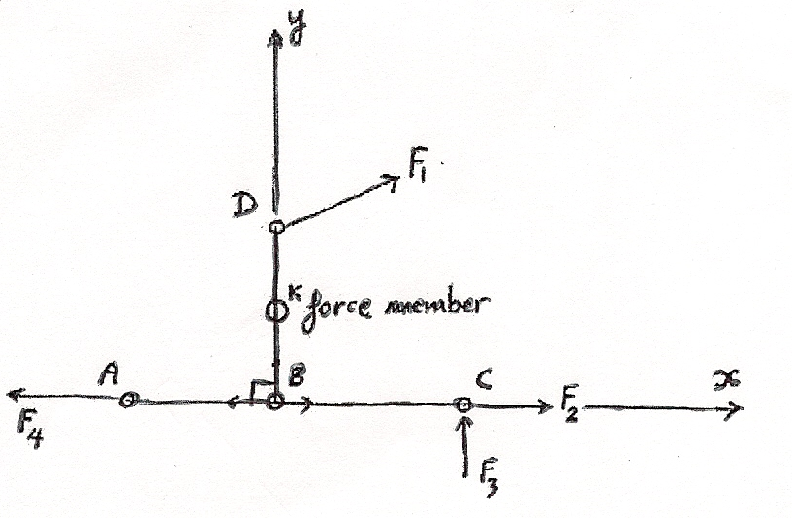
At Joint B:
$ΣF_{y}{}_{=}^{↑+}{ 0}$ = > 0 = $F_{BD}$

At Joint D:
$ΣF_{y}{}_{=}^{}{ 0= }F_{DA}\cos{α }$= > $F_{DA = }0$
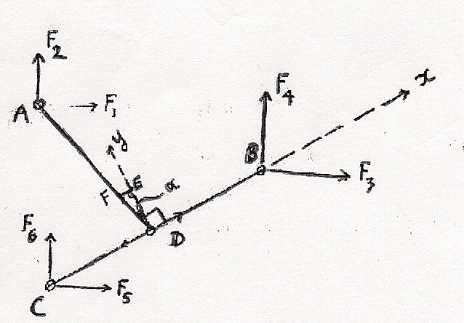
Rules
‘‘If we have 3 TRUSS members joining at a common joint (say, joint D), and if there are NO FORCES applied at the common Joint D, if two members form a 180º angle, such as members DB and DC, then the remaining member (such as member DA) should have Zero-force !’’
At Joint B;
$ΣF_{y}{}_{=}^{↑+}{ 0}={-F}_{BA}$
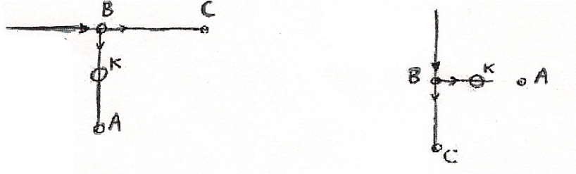
At Joint B:
$ΣF_{x}{}_{=}^{→+}{ 0}$ = $F_{BA}$

$C_{2}$) Multi-Force (Beam, Frame) Members
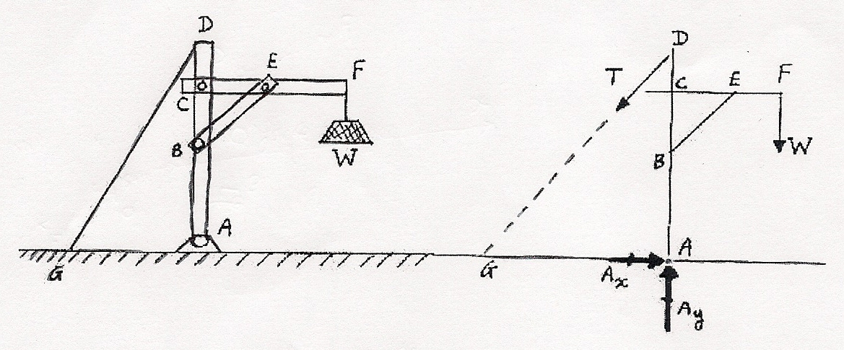

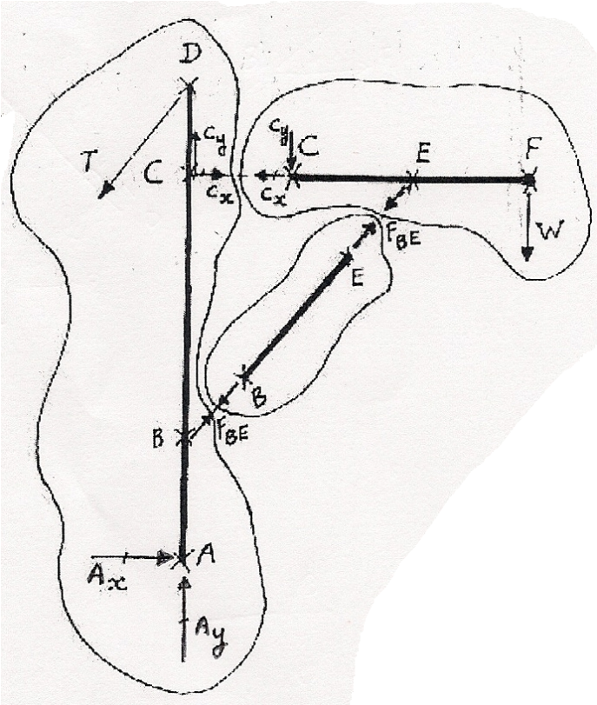
Notes:

- Members AD and CF are multi-force members
- Member BE is a 2 force (axial) member
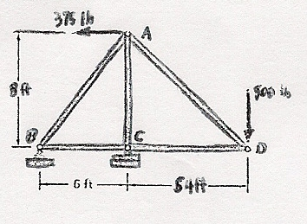
Problem 6.4
Using the method of Joints, determine the force in each member of the truss shown. State whether each member is in tension or compression

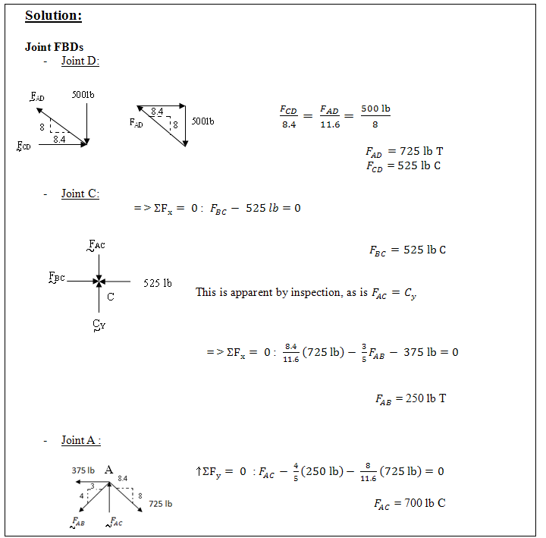

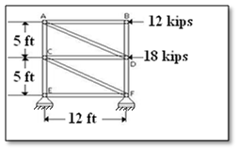

Problem 6.8
Using the method of joints, determine the force in each member of the truss shown. State whether each member is in tension or compression.

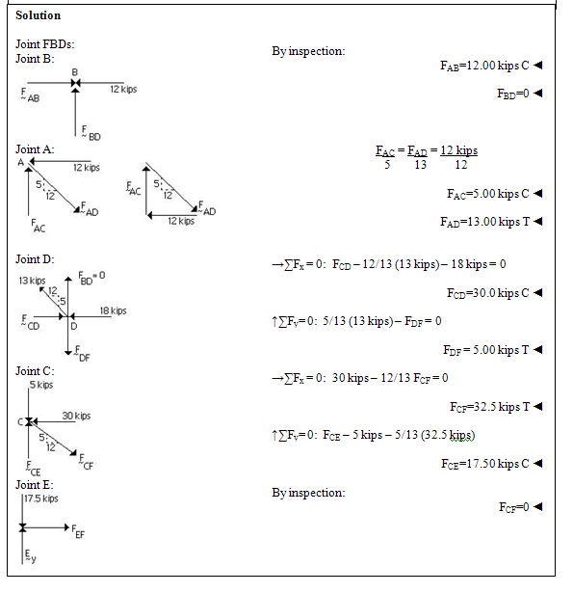

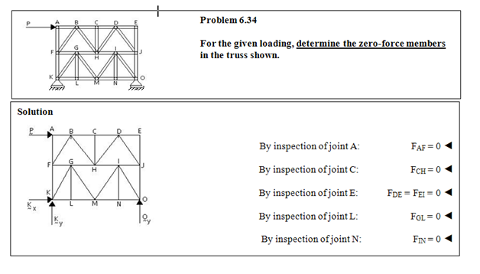

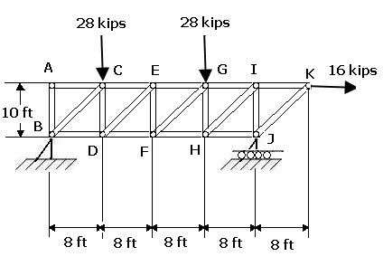
SAMPLE PROBLEM 6.2
Determine the force in members EF and GI of the truss shown.

SOLUTION:
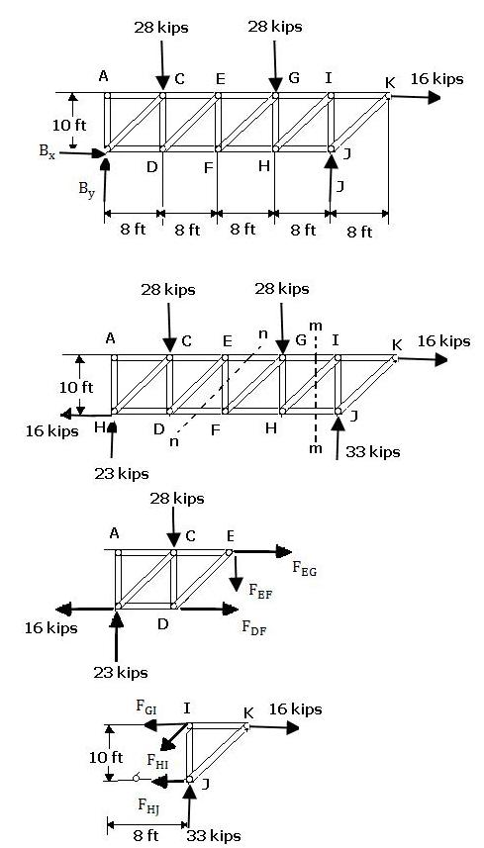
Free-Body: Entire Truss. A free-body diagram of the entire truss is drawn; external forces acing on this free body consist of the applied loads and the reactions at B and J. We write the following equilibrium equations.
$$\sum{M_{B}}=0:$$
$$-\left(28 kips\right)\left(8 ft\right)-\left(28 kips\right)\left(24 ft\right)- \left(16 kips\right)\left(10 ft\right)+J\left(32 ft\right)=0$$
J = +33 kips $J=33 kips ↑$
${}_{→}^{+}\sum{F_{x}}=0: B_{x}$ + 16 kips = 0
${ B}_{x}$ = -16 kips $B_{x}= 16 kips ←$
$$\sum{M_{J}}=0:$$
$$\left(28 kips\right)\left(24 ft\right)+\left(28 kips\right)\left(8 ft\right)- \left(16 kips\right)\left(10 ft\right)-B_{y}(32 ft)=0$$
$$B_{y}= +23 kips B_{y}=23 kips ↑$$

Force in Member EF. Section nn is passed through the truss so that it intersects member EF and only two additional members. After the intersected members have been removed, the left-hand portion of the truss is chosen as a free body. Three unknowns are involved: to eliminate the two horizontal forces, we write
$$+↑\sum{F_{y}}=0: +23 kips-28 kips-F_{EF}=0$$
$$F_{EF}= -5 kips$$
The sense of $F_{EF}$ was chosen assuming member EF to be in tension; the negative sign obtained indicates that the member is in compression. $F_{EF}=5 kips C$

Force in Member GI. Section mm is passed through the truss so that it intersects GI and only two additional members. After the intersected members have been removed, we choose the right-hand portion of the truss as a free body. Three unknown forces are again involved; to eliminate the forces passing trough point H, we write
$$\sum{M_{H}}=0: (33 kips)\left(8 ft\right)- \left(16 kips\right)\left(10 ft\right)+F_{GI}\left(10 ft\right)=0$$
$$F_{GI}= -10.4 kips F_{GI}=10.4 kips C$$

Chapter 7:
Forces in Beams and Cables

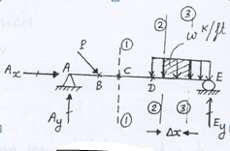
- Sign Conventions :

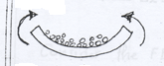
M= +
“Positive’’ end-moments (because the “rice” still
Remains inside the “bowl”)
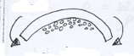
M= -
“Negative” end-moments (because the “rice” will fall-off
From the “bowl”, hence no rice left to eat! )

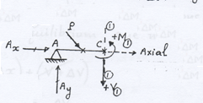

FBD of beam segment AC, where $V_{1}\&{ M }_{1}$ are internal shear force & bending moment in cut
section (1) – (1)

- Relations Between (Distributed) Loads “w”, Interval Shear Force “v”, and Bending Moment
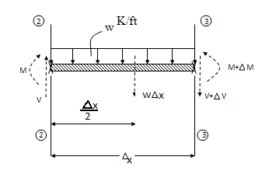
Consider the FBD of beam segment between cut-sections (2) – (2) and (3) –(3).
For Equilibrium, one has:

$$∑F_{y}{}_{=}^{↓+}{0=}-V+\left(w∙∆x\right)+\left(V+∆V\right)$$
$$0 = \frac{w∆x}{∆x}+\frac{∆V}{∆x}\overset{⇒}{ }\frac{∆V}{∆x}=-w$$

Let$∆x→0$ hence:$\boxed{\frac{dV}{ dx }=-w}$

$∑M_{(2)}=0^{+}=-M-\left(w∆x\right)\left(\frac{∆x}{2}\right)+\left(M+∆M\right)-(V+∆V)∆x$
$0=-w\left(\frac{∆x}{2}\right)+\frac{∆M}{∆x}-(V+∆V)$

Let $∆x→0$; hence $∆V→0$; and above eq. becomes:
$0=\frac{+dM}{dx}-V$; Or $\boxed{\frac{dM}{dx}=V}$
Or $\int_{(2)}^{(3)}{dM=\int_{(2)}^{(3)}{dx}}$

$M_{(3)}-M_{(2)}=$Area under shear curve, between cut-sections (2) and (3).

Basic Examples About Shear & Moment Diagrams

Example 1 (Concentrated Force Applied)
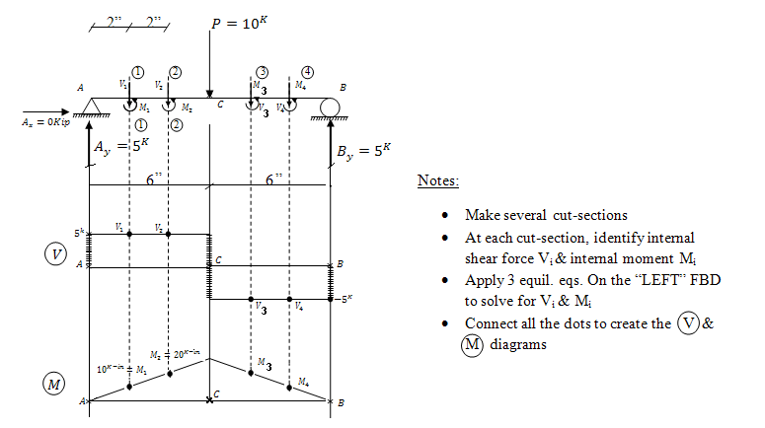
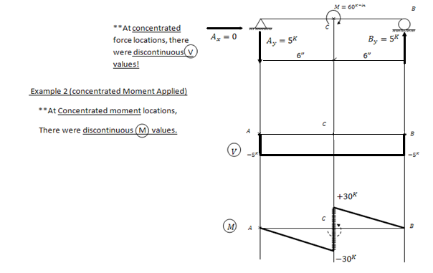

Quick Ways To Draw V & M Diagrams

To draw the internal shear diagrams:

“Look at the given beam structure, observe how the shear forces applied on the beam. Then, draw the V diagram accordingly”

To draw the internal moment diagrams:

Step 1: Refer to the shear diagram, and compute the areas under the shear diagram sections

Step 2: Compute the initial value of internal moment (including the proper sign) say $M_{ (1)}$

Step 3: Apply the formula: $M_{ (2) }–M_{ (1) }=$area under V diagram,
Between sections (1) & (2) to compute $M_{ (2) }$

Step 4: Decide how to connect the (two) dots in the M diagram
by referring to Eq. $\frac{dM}{dx}=V; or M_{ (2) }–M_{ (1) }=\int_{(1)}^{(2)}{Vdx}$

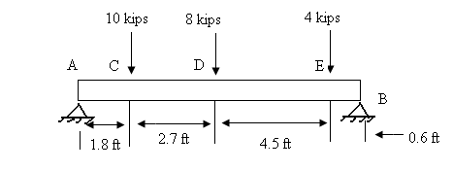
Problem 7.34
For the beam and loading shown, (a) draw the shear and bending-moment diagrams, (b) determine the maximum absolute values of the shear and bending moment.

Solution: (a)
FBD Beam:
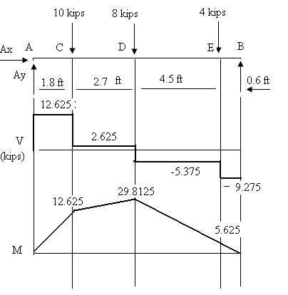
- $\sum{M_{B}}=0 :$
(.6 ft)(4 kips) + (5.1 ft)(8 kips) + (7.8 ft)(10 kips) – (9.6 ft) $A_{y}$= 0
$A_{y}$= 12.625 kips $↑$

$$↑ΣF_{y}= 0 :12.625 kips-10 kips-8 kips-4 kips+B=0$$

B = 9.375 kips $↑$

Along AC:
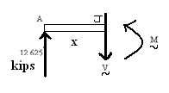
$$↑ΣF_{y}= 0 : 12.625 kips-V=0$$
V= 12.625 kips
$$ΣM_{j}=0 :M-x\left(12.625 kips\right)=0$$
M = (12.625 kips) x
M = 22.725 kip.ft at C
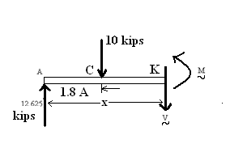
Along CD:

$$↑ΣF_{y}= 0 :12.625 kips-10 kips-V=0$$
V = 2.625 kips
- $ΣM_{k}=0 :M+\left(x-1.8 ft\right)\left(10 kips\right)-x\left(12.625 kips\right)=0$
M = 18 kip.ft + (2.625 kips)x
M = 29.8125 kip.ft at D (x=4.5 ft
Problem 7.34 Continued

Along DE:
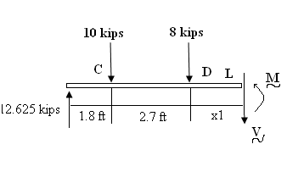
$↑ΣF_{y}= 0$ : (12.625 – 10 – 8) kips – V = 0, hence V = -5.375 kips
$$ΣM_{L}=0 :M+x_{1}\left(8 kips\right)+ \left(2.7 ft+x_{1}\right)\left(10 kips\right)- \left(4.5 ft+ x_{1}\right)\left(12.625 kips\right) =0$$

M = 29.8125 kip.ft - (5.375 kips) $x_{1}$

M = 5.625 kip.ft at E ($x_{1}=4.5 ft)$

Along EB:

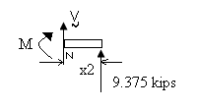

$$↑ΣF_{y}= 0 : V+9.375 kips=0 V=9.375 kips$$
- $ΣM_{N}= 0 : x_{2}\left(9.375 kip\right)- M=0$

M = (9.375 kips)$x_{2}$

M = 5.625 kip.ft at E

(b) From diagrams:

${\left|V\right|}_{max}$ = 12.63 kips on AC

${\left|M\right|}_{max}$ = 29.8 kip.ft at D

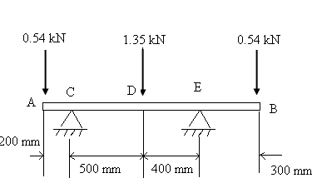
Problem 7.35

For the beam and loading shown, (a) draw the shear and bending-moment diagrams, (b) determine the maximum absolute values of the shear and bending moment.

Solution:
(a)
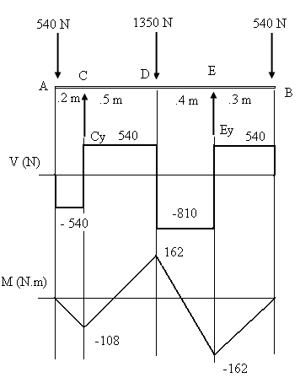
FBD Beam: $ΣM_{E}= 0:$

(1.1 m)(540 N) – (0.9 m)$C_{y}+\left(0.4 m\right)\left(1350 N\right)- \left(0.3 m \right)\left(540 N\right)=0$

$C_{y}=1080 N ↑$

$↑ΣF_{y}= 0:$ $E_{y}=$ 1350 N $↑$

Along AC:
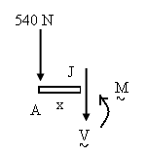
$↑ΣF_{y}= 0:$ -540 N- V= 0

V = -540 N
$ΣM_{j}= 0: x\left(540 N\right)+M=$ 0

M = -(540 N)x

Along CD:
$↑ΣF_{y}= 0:$ -540 N + 1080 N - V= 0 V = 540 N
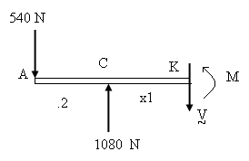
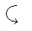 $ΣM_{K}= 0: M+\left(0.2 m+ x_{1}\right)\left(540 N\right)- x_{1}(1080 N)=0$

M = - 108 N.m + (540 N)$x_{1}$
M = 162 N.m at D ($x_{1}=0.5 m)$

Problem 7.35 continued

Along DE:

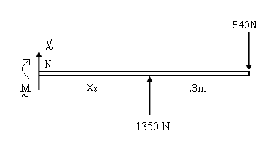

$↑ΣF_{y}= 0:$ V+ 1350 N – 540 N = 0 V = -810 N

$ΣM_{N}= 0: M+\left(x_{3}+ 0.3 m\right)\left(540 N\right)- x_{3}(1350 N)=0$

$M=-162 N.m + (810 N)x_{3}$
$$M=162 N.m at D (x_{3}=0.4)$$

Along EB:

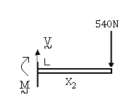

$↑ΣF_{y}= 0:$ V – 540 N = 0 V = 540 N

- $ΣM_{L}= 0: M+x_{2}\left(540 N\right)=0$ M = -540 N$x_{2}$
$M=- 162 N.m at E ( x_{2}=0.3 m)$

(b) From diagrams:

${\left|V\right|}_{max}$ = 810 N on DE

${\left|M\right|}_{max}= 162.0 N.m at D and E$

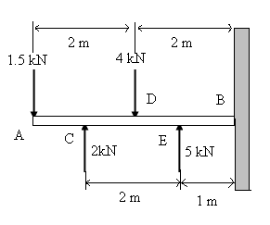
Problem 7.36

For the beam and loading shown, (a) draw the shear and bending-moment diagrams, (b) determine the maximum absolute values of the shear and bending moment.

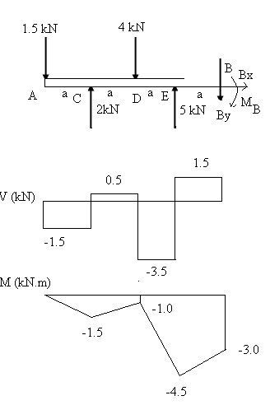
Solution:
- FBD Beam

a = 1 m ⇒ $ΣF_{x}= 0$ $B_{x}=0$

↑$ΣF_{y}= 0$ $-1.5 kN+2kN – 4 kN+5kN-B_{y}=0$

$B_{y}= 1.5 kN$

$ΣM_{B}= 0$ :
$$a[4(1.5 kN)– 3(2 kN) + 2(4kN)– 1(5kN] – MB= 0$$

$M_{B}= (3kN)a = 3kNm$

Along AC:
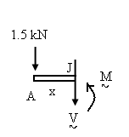

↑$ΣF_{y}= 0$ $-1.5kN – V= 0$

V= -1.5kN

$ΣM_{J}= 0: M-x(1.5 kN) = 0$ M(1 m )= - (1.5)x

Problem 7.36 Continued:

Along CD:

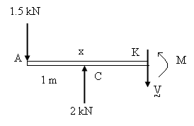
$↑ΣF_{y}= 0 : -1.5 kN + 2kN – V = 0 V= 0.5 kN$
$$Mk = 0 : M+ x(1.5 kN) – (x-1m)(2kN) = 0$$
$$M= -2 kNm + (0.5 kN)x M(2m) = -1kNm$$

Along EB:
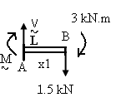
$↑ΣF_{y}= 0$ $V-1.5 kN=0$ V= 1.5kN

$ΣM_{L}= 0$: $-M-x_{1}(1.5kN) – 3kNm = 0$

$M = -3 kNm –(1.5 kN) x1$
$M(1m) = -4.5 kNm$

Along DE:

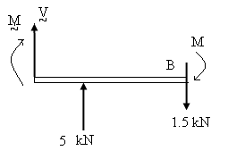

$↑ΣF_{y}= 0 : V + 5 kN – 1.5 kN = 0 V= -3.5 kN$

Also M is linear here

- ${\left|V\right|}_{max}=3.50 kN along DE$

${\left|M\right|}_{max}= 4.50 kNm at E$

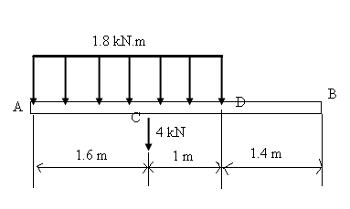
Problem 7.37

For the beam and loading shown, (a) draw the shear and bending-moment diagrams, (b) determine the maximum absolute values of the shear and bending moment.

Solution:
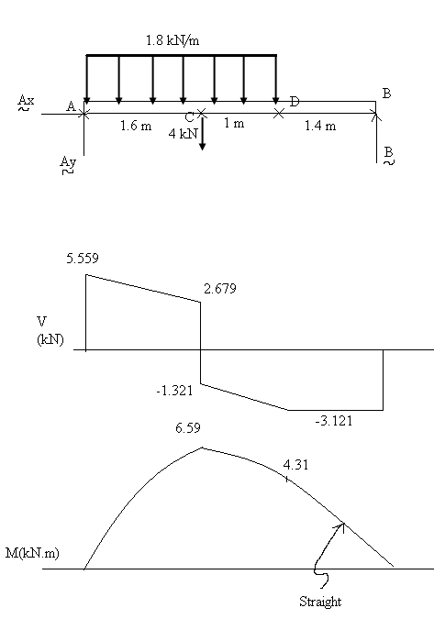
- FBD Beam
$$ΣM_{A}= 0:$$
$-\left(1.3 m\right)\left[(\frac{1.8kN}{m}\right)(2.6 m)]-(1.6 m)(4 kN)+(4 m) B=0$
$B = 3.121 kN↑$

$↑ΣF_{y}= 0:$
$${ A}_{y}-\left(1.8 kN?m\right)\left(2.6 m\right)- 4 kN+3.121 kN=0$$

$A_{y}=5.559 kN ↑$
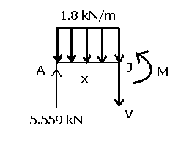

Along AC:
$$↑ΣF_{y}= 0: 5.559 kN-\left(1.8 kN/m\right)x-V=0$$
$$V=5.559 kN-\left(1.8 kN/m\right)x$$
$$ΣM_{J}= 0: M+\frac{X}{2}[(1.8 km)x]-x(5.559 kN)=0$$

$$M=(5.559 kN)x –(0.9 kN/m) x^{2}$$

Problem 7.37 Continued

Along CD:
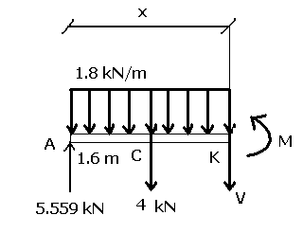
$$↑ΣF_{y}= 0: 5.559 kN-x\left(1.8 kN/m\right)-4 kN-V=0$$

$$V=(1.559 kN)-\left(1.8 kN/m\right)x$$

- $ΣM_{K}= 0: M+\left(x-1.6 m\right)\left(4 kN\right)+\frac{x}{2}[(1.8 km)x]-x(5.559 kN)=0$
$$M=6.4 kN.m+\left(1.559 kN\right)x-(0.9\frac{kN}{m})x^{2}$$

Along DB:

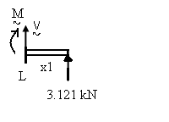

$$↑ΣF_{y}= 0: V+3.121 kN=0$$

$$V = -3.121 kN$$

- $ΣM_{L}= 0: -M+x_{1}(3.121 kN)=0$

$$M = (3.121 kN) x_{1}$$

$${\left|V\right|}_{max} = 5.56 kN at A$$

$${\left|M\right|}_{max}= 6.59 kN.m at C$$

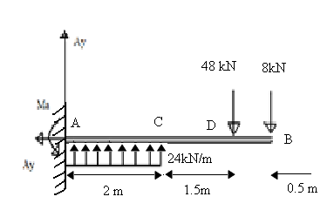
Problem 7.38
For the beam and loading shown, (a) draw the shear and bending-moment diagrams, (b) determine the maximum absolute values of the shear and bending moment.

Solution:
- FBD Beam:

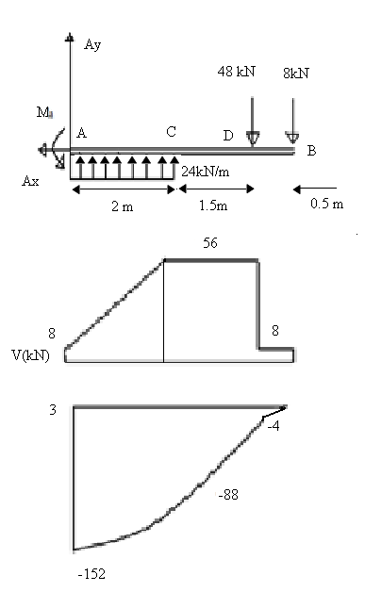
$←∑Fx=0: Ax=0$

$↑ΣF_{y}= 0 Ay+(2m)(24kN/m)-48kN-8kN=0$

$$Ay=8kN↑$$

- $∑M_{A}=0$ : $M_{A}+(1m)(2m)(24kN/m$)-(3.5m) (48kN)-(2m)(8kN)=0

M_{A}=152kN∙m

Along AC:
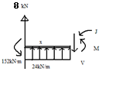

$$↑ΣF_{y}= 0: 8kN+x\left(24 kN.m\right)-V=0$$

$$V=8 kN +(24 kN/m)x$$

- $ΣM_{J}= 0: M+152 kN.m$
$$-x\left(8 kN\right)- \frac{x}{2}\left(24\frac{kN}{m}\right)x=0$$

$M = (12 kN/m) x^{2}+(8 kN)x - 152 kN.m$

Problem 7.38 Continued

Along DB:

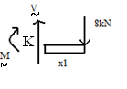
$↑ΣF_{y}= 0: V-8kN=0$

V = 8kN
$ΣM_{K}= 0: M+ x_{1}(8 kN)=0$ M = - (8kN)$x_{1}$

Along CD:

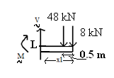

$$↑ΣF_{y}= 0: V-48 kN-8 kN=0, V=56 kN$$

- $ΣM_{L}= 0: M+\left(x_{1}- 0.5 m\right)\left(48 kN\right)+x_{1}\left(8 kN\right)=0 M=24 kN.m-(56 kN)x_{1}$

$${\left|V\right|}_{max}=56.0 kN along CD$$

$${\left|M\right|}_{max}=152.0 kN.m at A$$

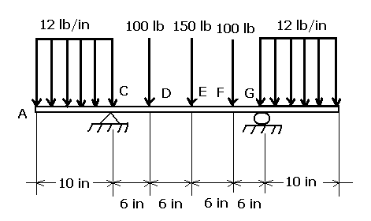
Problem 7.39

For the beam and loading shown, (a) draw the shear and bending-moment diagrams, (b) determine the maximum absolute values of the shear and bending moment.

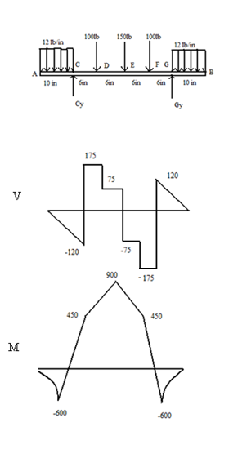
Solution:
(a) By symmetry, $C_{x}$ = 0, and
$C_{y}=G_{y}= \frac{1}{2}[2\left(12\frac{lb}{in.}\right)\left(10 in\right)+ 2\left(100 lb\right)+\left(150 lb\right)]$

$$C_{y}=G_{y}=295 lb↑$$
Along AC:
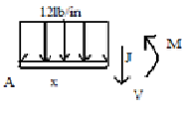
$$↑ΣF_{y}= 0: -\left(12\frac{lb}{in.}\right)x-V=0$$

$$V= -\left(12\frac{lb}{in.}\right)x$$
$$ΣM_{J}= 0: M+ \frac{x}{2}\left(12\frac{lb}{in.}\right)x=0 M= -(6\frac{lb}{in.})x^{2}$$
Along CD:
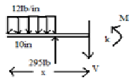
$$↑ΣF_{y}= 0: -\left(12\frac{lb}{in.}\right)\left(10 in.\right)+295 lb-V=0$$
$$V= 175 lb$$
- $ΣM_{K}= 0: M+\left(x-5 in.\right)\left(12\frac{lb}{in}.\right)\left(10 in.\right)-\left(x-10 in.\right)\left(295 lb\right)=0$

$$M= -2350 lb.in. +\left( 175 lb\right)x$$

Problem 7.39 Continued

Along DE:

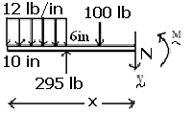

$$↑ΣF_{y}= 0: -\left(12\frac{lb}{in.}\right)\left(10 in.\right)+ 295 lb-100 lb-V=0, V=75 lb$$

$$ΣM_{N}= 0: M+\left(x-16 in.\right)\left(100 lb\right)- \left(x-10 in.\right)\left(295 lb\right)+ \left(x-5 in.\right)\left(12\frac{lb}{in.}\right)\left(10 in.\right)=0$$

$M= -750 lb.in+\left(75 lb\right)x$

- Complete diagrams using symmetry.

$${\left|V\right|}_{max}=175.0 lb along CD and FG$$

$${\left|M\right|}_{max}=900 lb.in at E$$

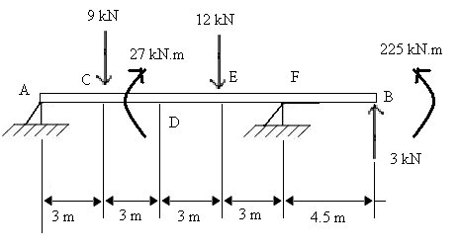
Problem 7.71

For the beam and loading shown, (a) draw the shear and bending-moment diagrams, (b) determine the maximum absolute values of the shear and bending moment.

Solution:

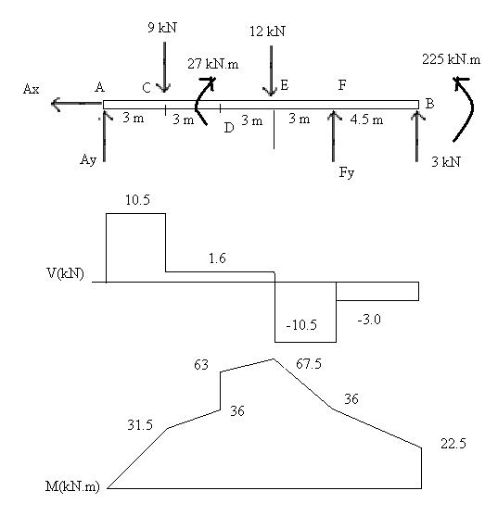
- $ΣM_{A}= 0: -\left(3m\right)\left(9 kN\right)- 27 kN.m-\left(9m\right)\left(12 kN\right)+ \left(12m\right)F+\left(16.5 m \right)\left( 3 kN\right)+ 22.5 kN.m=0$

$$F=7.5 kN ↑$$

$ΣF_{y}= 0: { A}_{y}- 9 kN-12 kN+7.5 kN+3 kN=0$

$${ A}_{y} =10.5 kN ↑$$

Shear Diag:
V is piecewise constant, with jumps at A, C, E, F, and B, equal to the forces there.

Moment Diag:
M is piecewise linear with jumps at D and B equal to the couples there.

$$M_{C}=\left(10.5 kN\right)\left(3 m\right)=31.5 kN.m$$
$$M_{D^{-}}=31.5 kN.m+\left(1.5 kN\right)\left(3 m\right)=36.0 kN.m$$
$$M_{D^{+}}=36 kN.m+27 kN.m=63 kN.m$$
$$M_{E}=63 kN.m+\left(1.5 kN\right)\left(3 m\right)=67.5 kN.m$$
$$M_{F}=67.5 kN.m-\left(10.5 kN\right)(3m)=36 kN.m$$
$$M_{B^{-}}=36.0 kN.m-\left(3 kN\right)\left(4.5 m\right)=22.5 kN.m$$

- From the diagrams:
$${ \left|V\right|}_{max}=10.50 kN along AC and EF$$
$${\left|M\right|}_{max}=67.5 kN.m at E$$

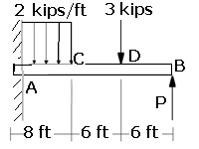
Problem 7.74
For the beam shown, draw the shear and bending-moment diagrams, and determine the maximum absolute value of the bending moment knowing that (a) P = 7 kips, (b) P = 10 kips.

Solution:

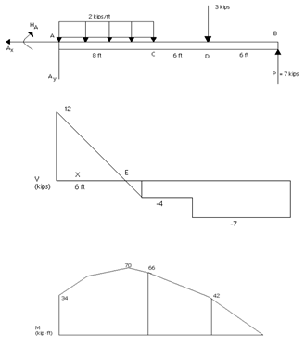
$↑ΣF_{y}= 0: A_{y}(2\frac{kips}{ft})(8 ft)$- 3kips + 7kips = 0
$A_{y}=12 kips ↑$
$ΣM_{A}= 0: M_{A}+ \left(4 ft\right)\left(2\frac{kips}{ft}\right)\left(8 ft\right)$
$$- \left(14 ft\right)\left(3 kips\right)- \left(20 ft\right)\left(7 kips\right)=0$$
$M_{A}= 34 kip.ft$

Shear Diag:
V jumps to 12 kips at A, then decreases at 2 kips/ft to -4 kips at C to D.
V drops 3 kips to -7 kips from D and B and jumps 7 kips to zero.
Note:
V = 0 where 12 kips – (2 kips/ft) x = 0, x = 6 ft.
Moment Diag:
M jumps to 34 kips.ft at A and then increases with decreasing slope to
34 kip∙ft + (12 kips) (6 ft) = 70 kip∙ft at E, and decreases by (4 kips) (2 ft) = 4 kip∙ft, to 66 kip∙ft at C. M then decrease by (4 kips)(6 ft) to 42 kip∙ft at D, and by (7 kips) (6 ft) to zero at B.
$${\left|M\right|}_{max}=70 kip.ft at E$$
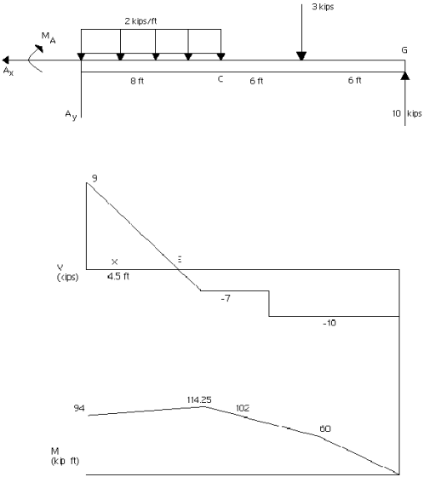

$$↑ΣF_{y} 0: A_{y}- \left(2\frac{kips}{ft}\right)\left(8ft\right)- 3 kips+10 kips=0$$
$$A_{y}=9 kips ↑$$
$$ΣM_{A}= 0: M_{A}+ \left(4 ft\right)\left(2\frac{kips}{ft}\right)\left(8 ft\right)+\left(14 ft\right)\left(3 kips\right)$$
$- \left(20 ft\right)\left(10 kips\right)=0$
$M_{A}= 94 kip.ft$
Shear Diag:
V jumps to 9 kips at A, then decreases, at 2 kips/ft, to -7 kips at C to D, drops 3 kips to -10 kips from D to B and jumps 10 kips to 0.
Note: V = 0 where 9 kips – (2 kips/ft) x = 0, x = 4.5 ft.
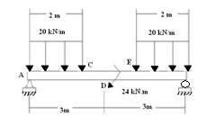 | Problem 7.76  For the beam and loading shown, (a) draw the shear and bending-moment diagrams, (b) determine the location and magnitude of the maximum absolute value of the bending moment.

Solution:
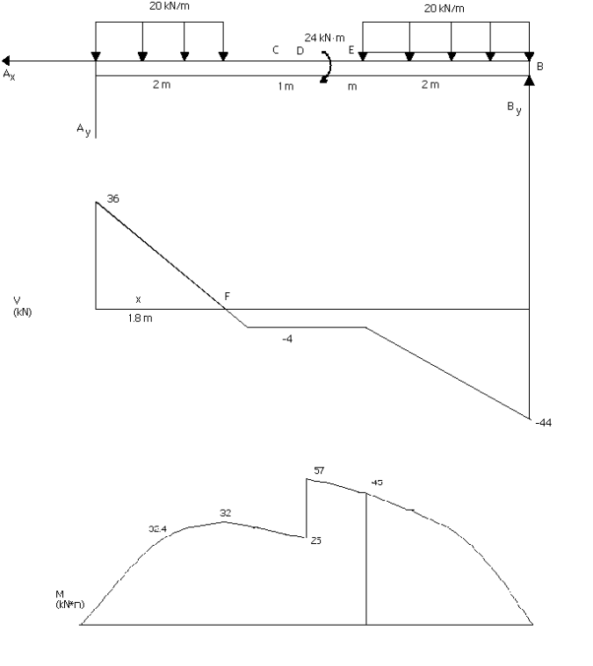
${}_{}^{+}{}ΣM_{A}=0:$
$$\left(6m\right)B_{y}- \left(1 m\right)\left(20\frac{kN}{m}\right)\left(2 m\right)- 24 kN.m-\left(5m\right)\left(20\frac{kN}{m}\right)\left(2m\right)=0$$

$$B_{y}=44 kN ↑$$

$$↑ΣF_{y}=0: A_{y}- 2\left(20\frac{kM}{m}\right)\left(2 m\right)+ 44 kN=0$$

$$A_{y}=36 kN ↑$$

Shear Diag:
V jumps to 36 kN at A, then decreases with slope -20 kN/m to -4 kN
at C, is constant to E, then decreases with slope -20 kN/m to -44 kN
at B.
Note: V = 0 at F where 36 kN – (20 kN/m)x = 0, x = 1.8 m.
Moment Diag:
Starting at zero M increases with decreasing slope to (36 kN)(1.8 m) = 32.4 kN∙m at F, decreases by (4 kN)(0.2 m) to 32 kN∙m at C, then with slope -4 kN to 28 kN∙m at D, where it jumps to 52 kN∙m, M decreases with slope -4 kN to 48 kN∙m at E, then with increasingly negative slope by (2 m) to zero at B.
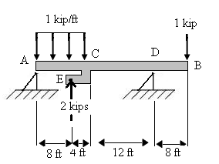

Problem 7.79
Solve Prob. 7.78 assuming that the 2-kip force applied at E is directed upward.

Problem 7.78: For Beam AB, (a) draw the shear and bending-moment diagrams, (b) determine the location and magnitude of the maximum absolute value of the bending moment.

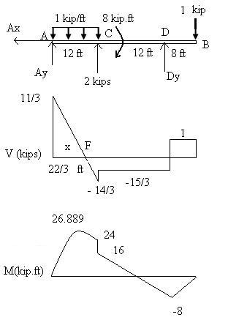
- Note: The 2 kip force at E has been replaced by the equivalent force and couple at C.
- $\sum{M_{AB}=0: -\left(6 ft\right)\left(1\frac{kip}{ft}\right)\left(12 ft\right)+ \left(12 ft\right)\left(2 kips\right)- 8 kip.ft+\left(24 ft\right)D_{y}- \left(32 ft\right)\left(1 kip\right)=0 }$
$D_{y}= \frac{11}{3} kips ↑$

$↑\sum{F_{y}}= 0: A_{y}- \left(1\frac{kips}{ft}\right)\left(12 ft\right)+ 2 kips- \frac{11}{3} kips-1 kip=0$
$$A_{y}= \frac{22}{3} kips ↑$$
Shear Diag:
Starting at $\frac{22}{3}$ kips at A, V decreases with slopes – 1 kip/ft to $\frac{-14}{3}$ kips at C, jumps 2 kips and remains constant at $\frac{-8}{3}$ kips to D, jumps $\frac{11}{3}$ kips and remains constant at 1 kip to B, drops to zero.
V = 0 at, where $\frac{22}{3}$ kip – (1 kip/ft)x = 0, x = $\frac{22}{3} ft$

Moment Diag:
Starting from zero, M increases with decreasing slope to $\frac{1}{2}\left(\frac{22}{3} kips\right)(\frac{22}{3}$ ft) = 26.889 kip.ft at F.
M increases by $\frac{1}{2}\left(\frac{14}{3} kips\right)(\frac{14}{3}$ ft) to 16 kip.ft at C, jumps to 24 kip.ft, decreases with slope $\frac{-8}{3}$ kips to – 8 kip.ft at D, and finally increases with slope 1 kip to zero at B.

$${ \left|M\right|}_{max}=26.9 kip.ft at F (7.33 ft from A)$$

